**CHAPTER 1**

**INTRODUCTION**

**1.1 About Robots**

A robot is an electromechanical device that is built to support and perform precision tasks that cannot be performed by conventional labor and continue24/7 with the same precision and accuracy. The robot is a combination of a bot that is built to support the laborious task with the internet and mechanisms. Another full form of the robot is the Random optical binary oscillating technology, which is built according to the task that has to be performed by the component.

The first robots were built to support the labor and achieve continuity in the work with different shapes and sizes. The robots are used in various industries for applications based on what is needed. Like in the manufacturing industry, robots are used for welding applications, pick-and-place work, painting, and many more. In advance, robots are built like humanoid robots, as shown in figure 1.1 below. Where the robot can perform the various advanced tasks with the support of Artificial intelligence and Internet of things, these robots are so advanced that they can answer any queries and task-related answers in real-time.

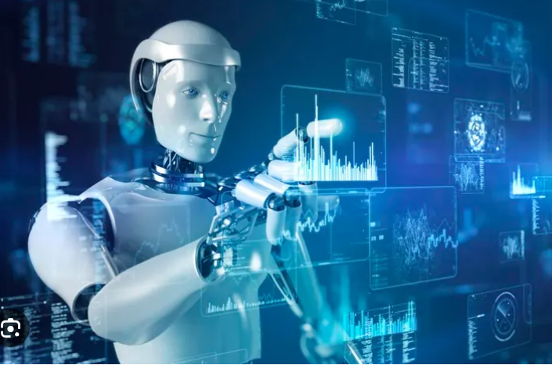

Fig. 1.1 Ideal robot for the AI task performing [1]

Looking at the above advancement in robotics, the low-cost humanoid robots are built to perform the basic tasks assigned and respond to the opponent as predefined FAQs. This robot is built using the 3D printing method so that the initial cost of the robot can be reduced for the current level. Here, various simple methods are used to optimize costs without compromising the quality of the task-related activities. These robots are built for simple tasks like line-followers, FAQs, and many more tasks.

**1.2 Evaluation of Robots**

The rise in automation led to the beginning of a modern era of robotics.TheUnimate, the first digitally controlled and programmable robot created in 1954 by **George Devol and Joseph Engelberger** as shown in the fig 1.2 below[2], They agreed on setting up a robotics company that could manufacture robots for industrial applications. This led to the foundation of a company named Unimaton, which produced in 1961 the first Unimate robot transformed production operations by handling materials and welding [2].

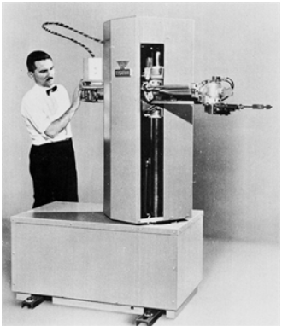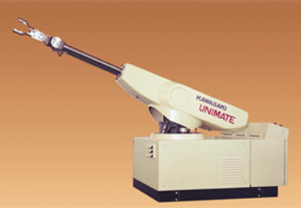One of thecompaniesin 1962 manufactured a new robot that was called “Versatran” (i.e. “versatile transfer”) [2] as shown in fig 1.2 below. It was a cylindrical robot that was ordered by “Ford” for its production plants in Canton (Ohio, USA) [2]

Fig. 1.2 Versatran robot [2] Fig 1.3 Unimate Robot[2]

In the 1968s-1977s the era of advancement in Robotics where Robots became more complicated and capable of performing a wide range and difficult tasks[2]. In around 1970 the microprocessor was introduced it allowed the robots greater control and programmability logic control [PLC] and some of them operated by teach pendent[2].These robots could not work a complex task and their level of versatility was not that much because the robot have their own software due to this they operate only specific tasks. It's very difficult to employ the same robot could be workingon a different task. Since the only diagnostic reports they could produce were those related to failures, which were reported by means of indicator lights, without any hint related to the cause of the failure that was left 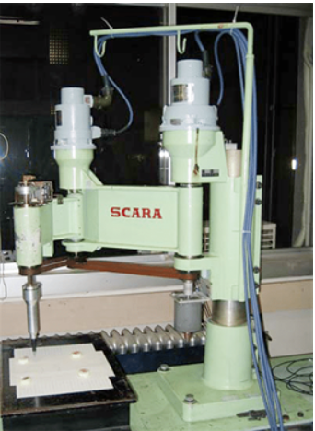to the operator to trace.

Fig 1.4 SCARA robot [2]

In 1978, a novel kinematic structure was proposed by the Japanese scientist Hiroshi Makino from Yamanashi University[2]. The structure was made of three revolute joints with parallel axes and a prismatic joint lying at the end of the kinematic chain. This type of robot structure was named SCARA ( “Selective Compliance Assembly Robot Arm”), since its compliance in the horizontal direction resulted in lower than compliance in the vertical direction[2].

The late 20th century was the era of personal and service robots designed for tasks such as cleaning, entertainment, and companionship. The sensor technology has contributed to the development of more autonomous and intelligent robots[2].

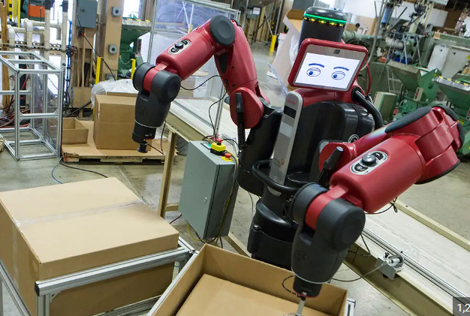Now in the 21st century, it has entered the next stage where humanoids and cobots are in existence which are associated with humans. It withstanding their capacity there are many difficulties and ethical challenges are posed[3]. Job opportunities will be reduced as there will be replacements by robots in the sectors of manual labor. There may be privacy and security problems as robots will be associated with sensors, cameras, and many more data-collecting and processing devices.

Fig. 1.5 Robotic Arms [4]

Some of the applications of the robots that were completely replaced by humans are as follows:

1. **Manufacturing**: Machine shops, (welding, Lifting, conveyors, Precision works, Medicine, and many more)
2. **Health care:** Surgeries (cardiac surgery, gynecological surgery), rehabilitation, companionship, etc.
3. **Surveillance:** It can be used for patrolling buildings and monitoring security cameras (drones, argus), etc.
4. **Hazardous places**: nuclear plants and chemical factories (high-temperature material handling, pipeline inspections, etc.)
5. **Agriculture**: It can be helpful in farming (planting, harvesting, and milking cows, etc.)
6. **Exploration:** Robots can go places that are too dangerous or inhospitable for humans, (deep sea, outer space, Volcano etc.)

**1.2.1 Present Day Robot**

The current trend and future advancements in the field of robotics AI and Machine learning are boosting the robot's ability to learn and tackle complex tasks. Looking ahead expect the robots become more work flawlessly with humans to enhance their life from several applications in the sector of industries, search, rescue, and healthcare, and hence robotics stand at the forefront of technologies[5]. This future holds the promise of robots increasing in efficiency, precision, and entirely new possibilities.

There are also seeing where robots are made with flexible materials, allowing them to interact with people more safely and navigate delicate environments.This could lead robots not just to follow instructions but also to make decisions and solve problems.

However, there are many challenges to consider. Ethical consideration surrounding robot development. Itneed to ensure robots are responsible and don’t replace human workers, and additionally, safety standards must evolve increasingly sophisticated robots.

* 1. **TYPES OF ROBOTS**

Robots are differentiated as per their task-performing areas in various applications, like, for example, industrial applications, which are called industrial robots.

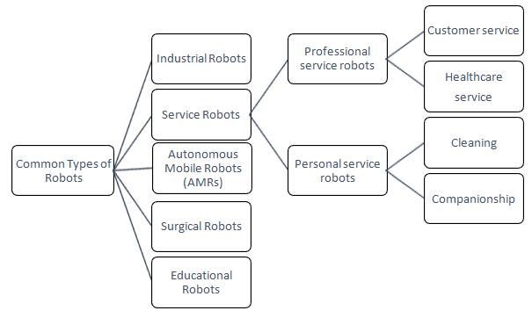

Fig. 1.6 Types of Robots [6]

**1.3.1 Industrial Robots:**

Designed for manufacturing tasks, these robots automate repetitive processes in industries such as automotive assembly lines. They excel in tasks like welding, painting, material handling, inspection, and testing. Industrial robots are especially for high durability for long periods. It can handle repetitive tasks. Industrial robots have different configurations with the most common being the articulated, resembling a jointed arm. Overall industrial robots are increasing efficiency and precision, safety in factories worldwide. While reducing human labor as shown in figure7.

**1.3.2Service Robots:**

These robots are intended to assist humans in various settings, including healthcare, hospitality, and household chores. They can perform tasks like cleaning, caregiving, and guiding, enhancing convenience and safety for users. It can be completely autonomous or collaborate with humans as shown in figure8 below.

**1.3.3Autonomous Mobile Robots (AMRs):**

These robots are essentially self-driving robots and navigate their surrounding without any human interference or following a fixed path. They are equipped with sensors and artificial intelligence, navigation systems to avoid the optical and plan their movement, and AMRs can move independently in dynamic environments without human intervention. They are used in warehouses for goods transportation, in agriculture for crop monitoring, and in search and rescue missions as shown in figure 9below.

**1.3.4 Surgical Robots:**

The surgical robotsutilized in minimally invasive surgeries, these robots enhance precision and dexterity for surgeons, reducing patient trauma and recovery time. It typically consists of several robotic arms with tiny surgical instruments attached, a high-definition 3D camera, and with surgeon’s console. They feature advanced imaging and robotic arms controlled by surgeons, enabling complex procedures with greater accuracy. Surgical robots are still in the developing stage of technology but they havea wide range use in cardiac surgery, gynecological surgery, etc. We can expect in the future to see even more adoption as shown in figure 10 below.

**1.3.5 Educational Robots:**

Designed to teach programming, engineering, and problem-solving skills, educational robots come in various forms, from simple kits to sophisticated platforms. They engage students in hands-on learning experiences, fostering creativity and technological literacy from an early age. They are transforming education by making learning more interactive, especially in the science, technology, engineering,and mathematics fields.The overall goal is to make good skills full foundation for their future as shown in Figure11.below.

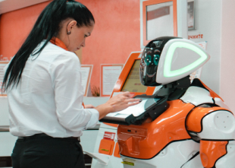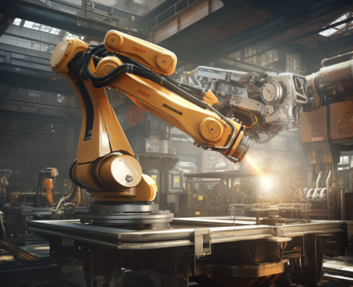

Fig.1.7Industrial Robot [7] Fig. 1.8 Service Robot [8]

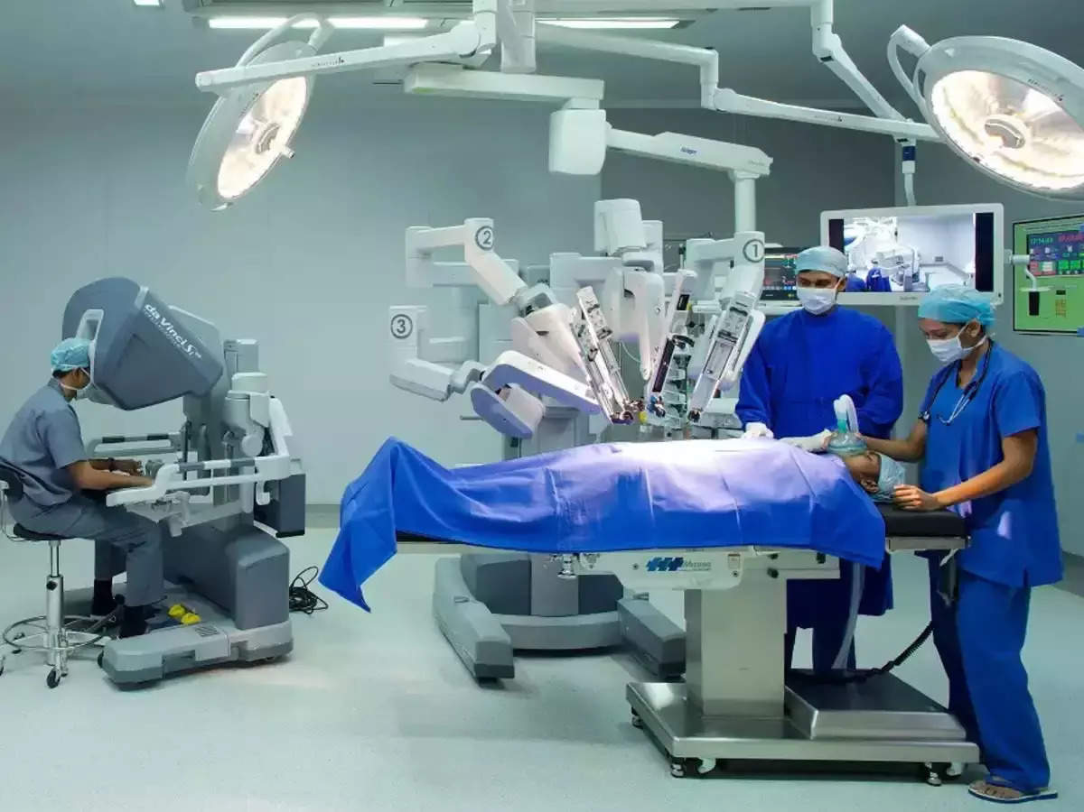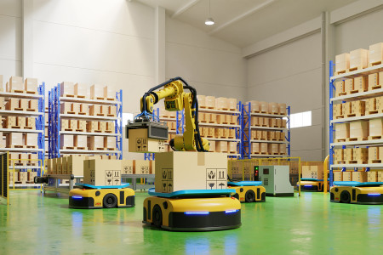

Fig. 1.9 AMR Robot [9] Fig. 1.10 Surgical Robot[10]

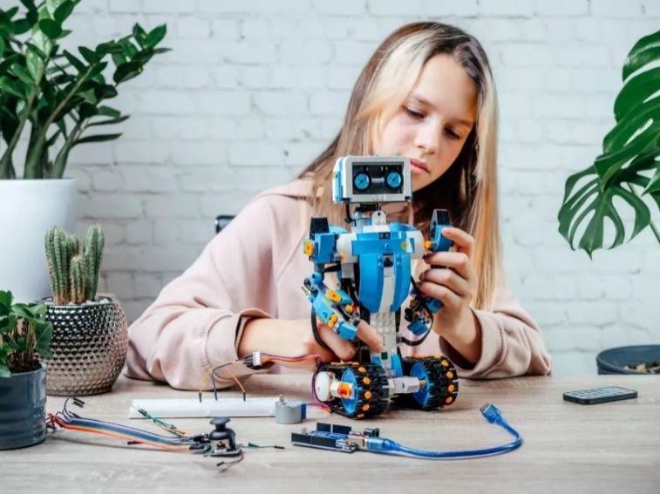

Fig. 1.11 Educational robot [11]

**1.4 SERVICE ROBOTS**

Service robots are autonomous or semi-autonomous machines designed to perform tasks for humans, typically in environments such as homes, offices, healthcare facilities, or public spaces. These robots are equipped with advanced sensors, actuators, and artificial intelligence to carry out various functions, ranging from simple household chores to more complex activities. Common examples include vacuum cleaning robots, delivery robots, and assistance robots for the elderly or individuals with disabilities.

Service robots aim to enhance efficiency, convenience, and safety in diversesettings, contributing to increased productivity and improved quality of life. With continuous advancements in technology, service robots are becoming more sophisticated andadaptable,ushering in a new era of human-robotcollaboration across various industries

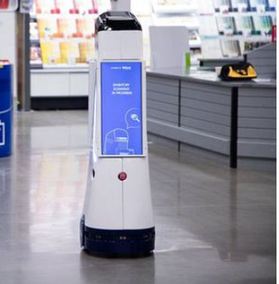

Fig. 1.12 Retail service robot [12]

* + 1. **TYPES OF SERVICE ROBOTS**

The service robots are differentiated by their applications and their specific special tasks

**A. Professional service robots are used in commercial settings to perform tasks such as:**

Logistics and delivery: These robots can autonomously transport goods within warehouses, hospitals, or even outdoors. For example, Amazon uses robots in their warehouses to move shelves of products around, which helps to improve efficiency and accuracy.

* **Customer service:** These robots can provide information to customers, answer questions, and even take orders. For example, some banks are using robots to greet customers and answer basic questions**.**
* **Healthcare:**

These robots can assist with tasks such as transporting patients, delivering medications, and performing surgery. For example, some hospitals are using robots to help surgeons perform complex procedures.

**B. Personal service robots are designed for use in homes and other personal settings. These robots can perform tasks such as:**

* **Cleaning:** These robots can vacuum floors, mop surfaces, and even clean windows**.**
* 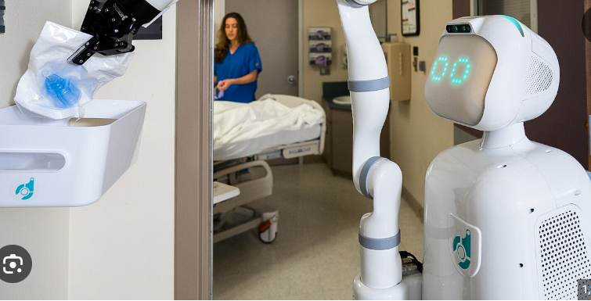**Companionship:** These robots can provide companionship to people who live alone or who are isolated.

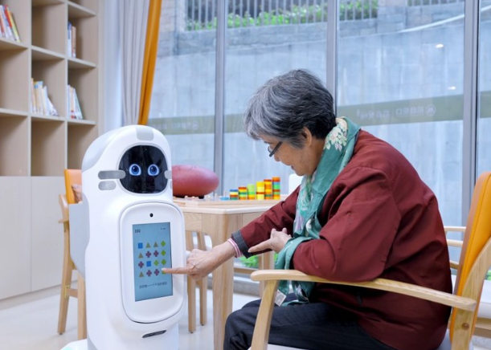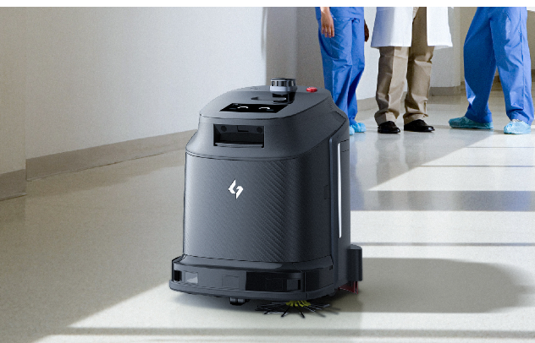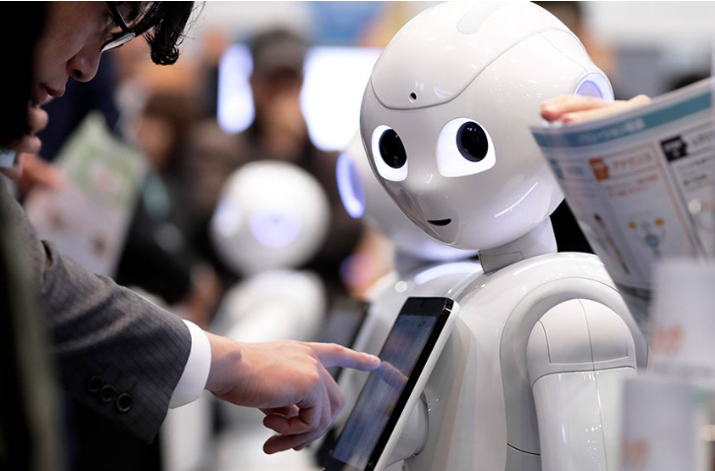Fig. 1.13 Customer service [13] Fig. 1.14 Healthcare [14]

Fig.1.15 Cleaning [15] Fig. 1.16 Companionship [16]

**1.4.2.1 Humanoid Service Robot (Personal Robot):**

Based on the literature survey we are designing a human-like body of robot. It assists individuals in their home and personal work or tasks. To make it low-cost effective we are using the 3D printer for making body parts. The robot's helpful companion it interactive in a more natural way compared to traditional. It has many potential functions for daily human tasks like reminding schedules, appointments, and medications.

Robots use sensors to perceive their environment. Face detection helps recognize people while tracking follows their movements. Obstacle avoidance with infrared helps navigate safely. Integration with robot functions allows personalized actions. Line following uses sensors to navigate paths. Text-to-speech lets robots communicate information.

Here are some of the humanoid robot features:

* **Face detection**: The extracted features are then compared against known patterns or templates of human faces stored in the system's database. This comparison helps determine whether the detected region is indeed a human face.
* **Face tracking:** In dynamic environments, where faces may move or appear/disappear from the camera's field of view, face detection systems often incorporate tracking algorithms. These algorithms help the robot keep track of detected faces over time, enabling it to maintain awareness of people's presence and movements.
* **Obstacle avoiding:** Infrared sensors detect obstacles by emitting infrared light and measuring the reflection. They are particularly useful for detecting objects at close range. The robot's control system executes the planned path while continuously adjusting its trajectory to avoid obstacles in real-time.
* **Integration with Robot's Functions:** Once faces are detected and identified, the robot can integrate this information into its decision-making processes or actions. For example, a service robot may use face detection to greet specific individuals, provide personalized assistance, or navigate around people in crowded environments safely.
* **Line following:** Line-following robots typically use sensors, such as infrared (IR) sensors or light sensors, to detect the contrast between the line and its surrounding surface. These sensors provide feedback to the robot's control system
* **Text to speech:** The process begins with the robot receiving textual input. This input can come from various sources such as user commands, pre-programmed responses, or information retrieved from databases or the internet.

**1.5LITERATURE SURVEY**

* **Kruthika K et al [17]-** This paper presents the development of 5 DOF robotic arms for feeding elderly and disabled people. The arm is controlled through GUI inputs. The principle used is the kinematics of the robot and MATLAB. Forward kinematics was used to position and orientation of an end effector. Proteus, Arduino IDE, and processing were used to test the functionality of the arm. The use of Arduino MEGA2560 I/O board, potentiometers, DC motors, and force sensors are used to enhance the functionality. This paper failsto discuss the challenges faced during the design and development of the arm.
* **He Shen et al [18] –** This paper talks about the design, development, and verification of a low-cost, lightweight robotic manipulator that can achieve human hand movements. The developed arm was of length 31 inches and of weight 7 pounds. They have used 3D printed parts using polylactic acid and nylon and used 2 servo motors and 3 brushless DC motors. It has demonstrated a comparable performance of a robotic arm to an anthropomorphic arm at a reduced cost.
* **Christina Souyoung Song et al [19] -** This study explores how Retail Service Robots (RSRs) utility, sociability, and look impact on human-robot interaction positively. The study included video clip stimuli, interviews, and empirical data gathering from food service technology and fashion industries with a sample size of 1362. It anticipates better service quality and greater acceptance of RSRs but it has limited the generalizability of the results by focusing only on three sectors i.e. fashion, technology, and food service.
* **B. Madhusanka et al [20]** – This study focuses on using eyes as an input device for enhancing human-robot interaction by developing an attentive robot eye for a service robot. Object searching development was completely implemented by OpenCV software and the CAMShift algorithm. It created object trajectories by locating the positions of objects in the video frames.

The viewing angle was limited compared to humans and the power supply through the electrical circuit was especially taken care of due to its potential limitations.

* **Z. A1 Barakeh et al [21]** – The paper discusses the rise of humanoid robots in daily life, focusing on mobility, acting, and communicating like humans in certain tasks or hazardous situations. It also proposes a review of projects utilizing humanoid robots as service robots, with a scenario framework for a humanoid robot pepper, as a service robot in the American University of Middle East. It discusses the framework of implementing pepper. It also discusses the interest of the public in service robots in Kuwait. This paper does not discuss the challenges faced and the technical aspects of the robot.
* **C. Hwang et al [22]** – This paper realizes the humanoid robotic system to service the customers in N tables, and to deliver the meal to the customer. It has 26 degrees of freedom, a wheeled vehicle with navigation ability, and a counter with order selection and task allocation. Orders from tables are transmitted via Bluetooth module. Here based on the lines on the ground, the line follower system and navigation strategy and communication are proposed.
* **M. Diftler et al [23]** – This paper discusses the mobile autonomous robot for assisting human co-workers at Jhonson Space Center with handling tools. This mentions the combination of the robots’ upper body of the NASA Robonaut system with a mobility platform which yields humanoid perfect for aiding human coworkers in a range of environments. It uses the stereo vision to locate human teammates and tools. It also has a navigation system that uses laser range and vision data to ignore objects and fellow humans. Use of tactile sensors for providing information about grasping algorithms for tool exchanges.
* **K. Miura et al [24]**- This paper presents a study on humanoid robots to evaluate assistive devices, demonstrating a decrease in torque for lifting with passive support wear. This involves pilot experiments done using a humanoid robot. The motion was obtained from the retargeting technique and the supportive effect was estimated through simulation. The limitation is, that there are no properly specified components used and functions.
* **Kanggeon Kim et al [25]**- This study describes the development of network based humanoid robots in home environment. This paper also introduces coordinated framework which provides human robot interaction. It also has face, voice and object recognition. Using task script the robot is instructed to complete the proposed tasks. Here the system simultaneously doesnot work being the limitation it can assist humans.
* **T. Nishiyama et al [26]**- This paper discusses about the development of user interface for a humanoid service robot system. The proposed system has ability of walking and four types of user interfaces. It has extended library system robot avatar agent for control and These interfaces allowed different users to control the robot in different ways, including nurses, patients, and people at remote sites.Users could select words that could be converted into actionable commands for the robot system using the network-based user interface, which translated utterances into motions for the humanoid robot .The 'FOMA' phone, a portable device with a small camera, was also taken into consideration for taking pictures to be shown on the robot's LCD screen.
* **Yoonseok pyo et al [27]**- This paper introduces a service robot with an informationally structured environment that integrates data from distributed sensors for motion and includes object detection , motion planning and human robot interaction. The information collected is stored in the online database .The object detection using RGB-D camera and motion planning through wagon. For positioning and human-system interaction, the ROS-TMS system makes use of a range of sensors, including the Vicon MX, TopUrg, Velodyne 32e, and Oculus Rift. Challenges in sensing all necessary information in complex environment needed more effective sensors.
* **Mitthias Seitz et al [28]** – This paper discusses integration of vision with gripping and object recognition. Vision is integrated into a highly redundant robot system with a tiltable camera with very acute angles and contour image processing with low quality. It has offline grasping capability. The movement of the hand, eye, and arm are according to the requirements one after the other.
* **A.Steele [29]** – This paper describes the challenges and limitations of current robotics and construction of bipedal walking system. It introduces biomimetic designs and using the locking up strategy for joints. All parts are printed using 3D printer which makes it light in weight.

But this is very complex to build all the joints and anatomy perfectly and using a wheeled robot has the required speed.

* **Zhangguo Yu et al [30]** – This paper focuses on design and development of humanoid robot, with mechanical structure and control systems. An open control architecture based on concurrent multicahnnel communication mode of CAN bus is proposed to upgrade the real time communication performance and the expansion of control system. Casting manufacturing method is used to integrate.enhancing stiffness and reliabitlity through design was the challenge and evaluating stability of humanoid motion using the zero moment point . casting was also a limitation.
* **Santiago Martinez et al [31]-** This paper discusses about developing applications for huamnoid robots using third party tools and cloud data sharing, streamlinig communication software modules for efficient development. It avoids complex communication software modules. Use of clou technologies for data sharing to facilitate intercommunication between systems. It lacks of standardization in middlewears causing delays. Bridges between those are not easily adaptable. Cloud communication is not in real.
* **Prakash K R et al [32]-** this paper presents the development of humanoids for indoor applications focusing on medical tasks. It utilized 3D printing for cost-effective parts and Arduino uno for control for service tasks. It has arm moments with Arduino uno control to deliver needed medicines. Head parts are 3D printed with ABS plastic and joined with the help of nuts and bolts. The paper provides only the head part and the turtlebot surface of upper body not the movement of the robot. The next stage is carried by this projet on wheels movement.
* **Kiran Somisetti et al [33]-** In this paper the authors have presented an experiment with humanoid robots for civilians. Designed through programming and controlled by microcontrollers for the results of dof and position of robots. First solidworks software was used for design later V-rep software was used. Sensors, mechanisma, robots and whole systems can be modelled and simualted in V-rep. It was fabricated using 3D printing with PLA plastic. Rasberry pi used will give the commands for arduino to control motions. The developed robot was able to perform certain set of operations efficiently.
* **Kittiwad Kantharak et al [34]-** In this paper, the service robot named “Black Bot” as recepionist is described. It is a three-wheeled robot controlled by mechanical actuators and various electronic sensors. It is based on dc servomotors based on differential drive. It has nonholonomic structure, containing an internal frame for the required strength and stiffness for locomotion. It has clearly designed screen for communication. Image processing provides a larger vision to the real world.
* **Ruth Stock et al [35]-** This research compares human-robot interaction with human-human interaction. The experiment carried out in a room made look like a hotel lobby intended to welcome guests. The results was positive with customer satisfaction and delight. The robot was handed by experimenter behind the screen. But all customers thought it was acting autonomously.

This paper study includes the mimic of human arm for humanoid robot. The arm is built by using PMDC motors, gear trams, breaks and motor drives. The design is having 7 dof similar to human and controlled by the microcontroller PIC 18F4580. Flexi force sensor is used to get the amount of force attached to each finger. Modular arm developed is more suitable for human interactions and can handle upto 3 kgs of payload.

**1.5 Summary:**

By observation of the above Literature survey some of the following points are observed and motivated for this project work

* In article by Jennifer Wang [15] is a gripping story of the difficult road that goes from idea to finished humanoid service robots,
* Wang provides insightful information about the difficulties and successes faced during the design and development stages by carefully examining them, Wang skilfully handles legal issues and technical intricacies, emphasizing the necessity for multidisciplinary cooperation and creative solutions
* The research emphasizes the significance of painstaking attention to detail and iterative refinement in producing a functioning and user-friendly robot, from original ideation to prototype and testing.

This literature survey offers helpful advice for maximizing the potential of humanoid service robots in a variety of applications, making it an inspirational read for budding roboticists and engineers.

**1.6 Problem Statement**

Developing Cost-Effective Humanoid Service Robots There's a growing need for affordable and versatile service robots to automate tasks in various environments. However, current humanoid robots are often expensive due to complex manufacturing and advanced technologies.

**1.7 OBJECTIVE OF WORK**

* To build cost-effective humanoid serving robots, using 3D printing and cost-effective materials
* To serve various features like Face detection, Face tracking, obstacle avoidance, Line following, Text-to-speech, etc.
* The robot should work and integrate with suitable modes like online and offline and devices
* The robots should be working on wireless machines that can be operated in various terrains.